SIMATS ENGINEERING
NAME:JENITHA JOTHI J.
REGISTER NO: 192520013
MARKS: /100
ASSESSMENT TOOL 1

COURSE NAME: Database Management Systems
COURSE CODE: CSA05

COURSE OUTCOME COVERED

CO2: Apply the relational model, relational algebra, SQL query structures, and views to solve database querying and data manipulation problems. (BL3, BL6)

Activity Tool : Analytical Problem Solving (High)
Assessment Tool Weightage: 35%

Dr

QUESTIONS Total Marks: 50
Q.No | Question | Bloom's Level | Marks
1 | Apply relational algebra operations (σ, π, ∪, -, ×, ⋈) on the given Employee and Department relations to retrieve required records. | BL3 – Apply | 5
2 | Write SQL DDL statements to create STUDENT(SID, Name, DOB, DeptID) and DEPARTMENT(DeptID, DeptName) tables with all appropriate constraints. | BL3 – Apply | 5
3 | Formulate SQL queries using GROUP BY, HAVING, and aggregate functions (COUNT, SUM, AVG, MAX, MIN) on a given Sales dataset. | BL3 – Apply | 5
4 | Write a correlated sub-query to find employees earning more than the average salary of their own department. | BL3 – Apply | 5
5 | Apply all types of JOIN operations (INNER, LEFT OUTER, RIGHT OUTER, FULL OUTER, CROSS) on Employee and Project tables. | BL3 – Apply | 5
6 | Create a view 'DeptSalaryView' that displays department name, total employees, and average salary. Write a query on this view. | BL6 – Create | 5
7 | Construct a relational algebra expression for the following: Find names of students who are enrolled in all courses offered. | BL6 – Create | 5
8 | Write SQL DML statements (INSERT, UPDATE, DELETE) with integrity constraint enforcement for a given scenario. | BL3 – Apply | 5
9 | Apply tuple relational calculus to express a query: Find all employees who work in the 'IT' department and earn more than 50000. | BL3 – Apply | 5
10 | Design a relational schema for an Airline Reservation System and write 5 SQL queries demonstrating joins, sub-queries, and views. | BL6 – Create | 5

Code of Conduct:

I __JENITHA JOTHI J.___192520013_______________ (Name / Reg No) certify that this submission is my original work and that I have adhered to the guidelines specified for this assessment.
I understand that any violation of academic integrity rules will result in disciplinary action.

Signature of the student:
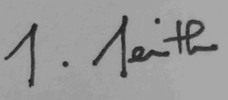

RUBRICS FOR CALCULATION:

Numerical Problems
Criteria | Weightage | Level 4 (Exemplary) | Level 3 (Proficient) | Level 2 (Developing) | Level 1 (Beginning)
Problem Understanding | 20% | Clearly interprets problem, identifies all parameters and requirements accurately | Understands problem with minor gaps | Partial understanding; misses key elements | Misinterprets or unable to understand problem
Method Selection | 20% | Selects most appropriate method/formula with strong justification | Selects correct method with minor errors | Inappropriate or partially correct method | Unable to select method
Solution Process | 25% | Logical, systematic steps with correct approach throughout | Mostly correct steps with minor mistakes | Disorganized steps; multiple errors | No clear process
Accuracy of Calculation | 20% | All calculations accurate; correct final answer | Minor calculation errors | Frequent errors; incorrect final answer | No valid calculations
Interpretation of Results | 15% | Clearly interprets results with units and engineering relevance | Basic interpretation with minor omissions | Limited or unclear interpretation | No interpretation

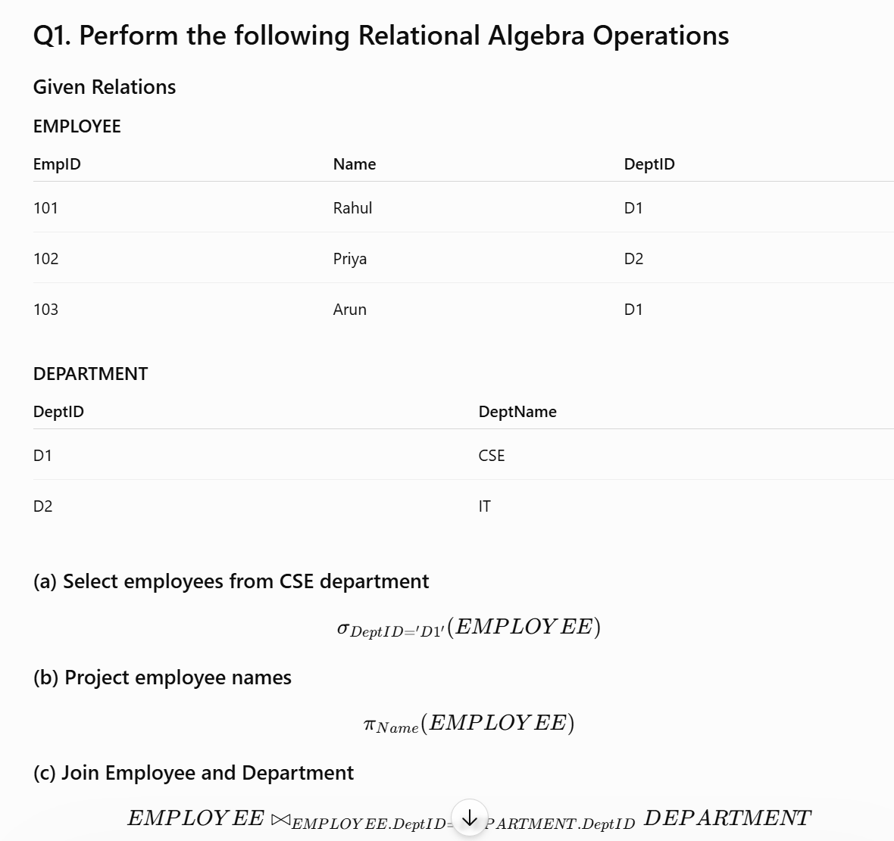

Q2. Create DDL statements

CREATE TABLE Student(
StudentID INT PRIMARY KEY,
Name VARCHAR(30),
Department VARCHAR(20),
Age INT
);

CREATE TABLE Course(
CourseID INT PRIMARY KEY,
CourseName VARCHAR(30),
Credits INT
);

CREATE TABLE Enrollment(
StudentID INT,
CourseID INT,
Semester VARCHAR(10),
PRIMARY KEY(StudentID,CourseID),
FOREIGN KEY(StudentID) REFERENCES Student(StudentID),
FOREIGN KEY(CourseID) REFERENCES Course(CourseID)
);

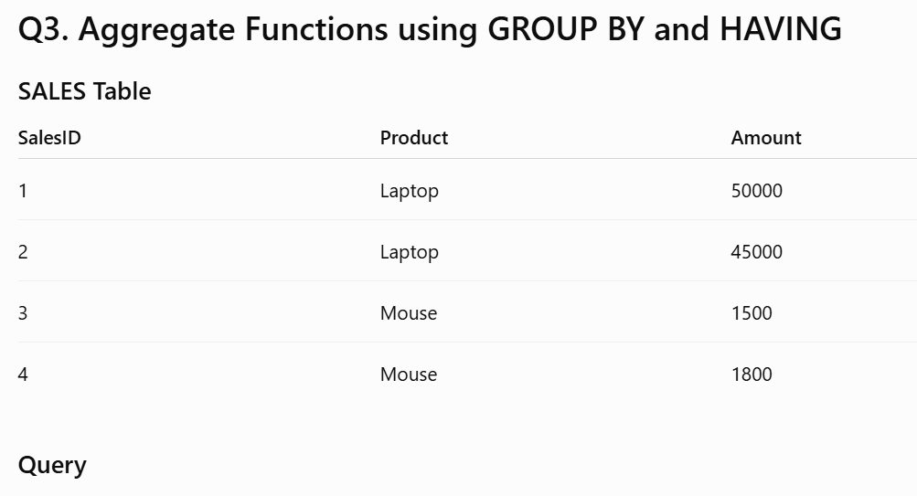

SELECT Product,
COUNT(*) AS TotalSales,
SUM(Amount) AS TotalAmount
FROM Sales
GROUP BY Product
HAVING SUM(Amount)>3000;

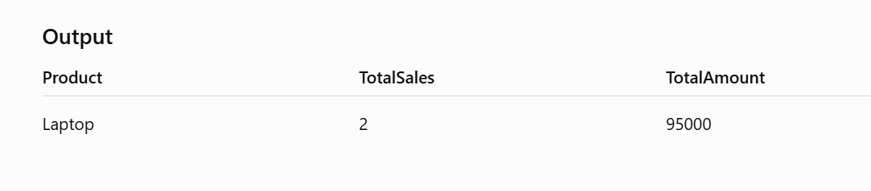

Q4. Correlated Subquery

SELECT Name,Salary
FROM Employee E
WHERE Salary>
(
SELECT AVG(Salary)
FROM Employee
WHERE DeptID=E.DeptID
);

The query displays employees whose salary is greater than the average salary of their respective department.

Q5. Demonstrate JOIN Operations

Inner Join

SELECT E.Name,D.DeptName
FROM Employee E
INNER JOIN Department D
ON E.DeptID=D.DeptID;

Left Join

SELECT E.Name,D.DeptName
FROM Employee E
LEFT JOIN Department D
ON E.DeptID=D.DeptID;

Right Join

SELECT E.Name,D.DeptName
FROM Employee E
RIGHT JOIN Department D
ON E.DeptID=D.DeptID;

Full Outer Join

SELECT E.Name,D.DeptName
FROM Employee E
FULL OUTER JOIN Department D
ON E.DeptID=D.DeptID;

Q6. Create a View and Retrieve Data

Create View

CREATE VIEW Employee_View AS
SELECT EmpID, Name, DeptID
FROM Employee;

Retrieve Data

SELECT * FROM Employee_View;

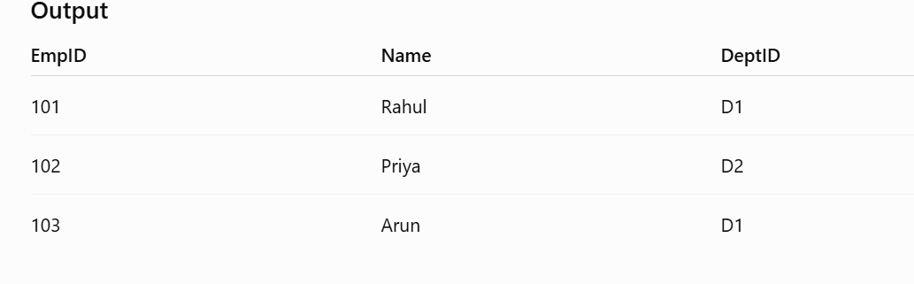

Q7. Demonstrate Relational Algebra Division Operation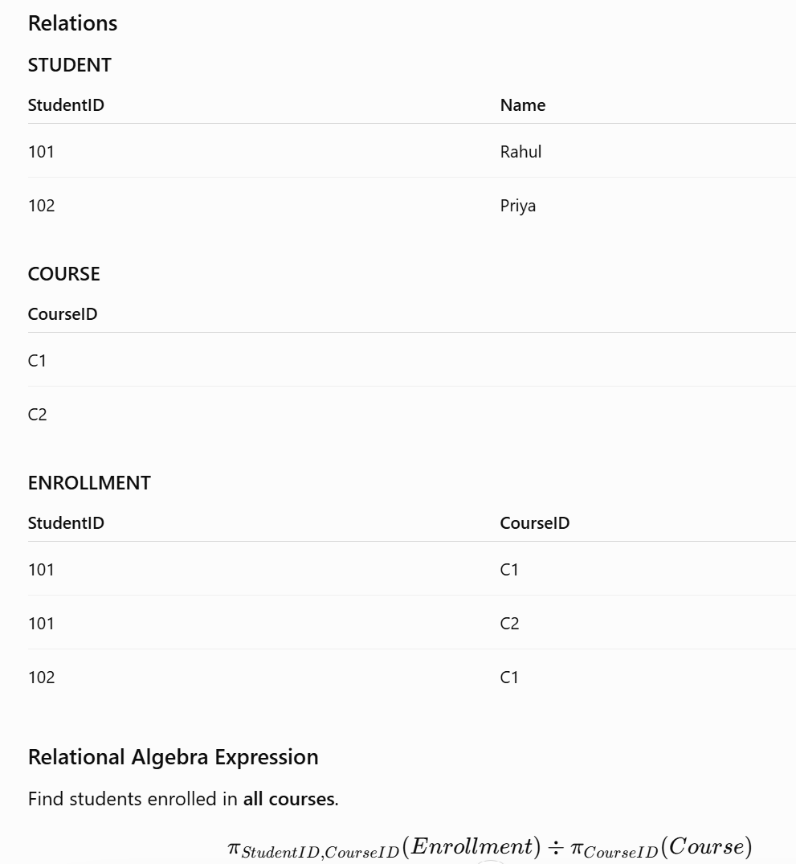

Q8. Perform DML Operations

INSERT INTO Employee
VALUES(104,'Karthik','D2',35000);

UPDATE Employee
SET Salary=40000

WHERE EmpID=104; DELETE FROM Employee
WHERE EmpID=104;

Q9. Demonstrate Tuple Relational Calculus (TRC)

Relation
Employee(EmpID, Name, DeptID, Salary)

Query
Retrieve the names of employees working in the CSE (D1) department.

{ t.Name | Employee(t) ∧ t.DeptID = 'D1' }

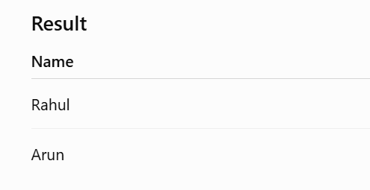

Q10. Design an Airline Reservation Database

CREATE TABLE Passenger(
PassengerID INT PRIMARY KEY,
Name VARCHAR(30),
Phone VARCHAR(15)
);

CREATE TABLE Flight(
FlightID INT PRIMARY KEY,
FlightName VARCHAR(30),
Source VARCHAR(30),
Destination VARCHAR(30)
);

CREATE TABLE Reservation(
ReservationID INT PRIMARY KEY,
PassengerID INT,
FlightID INT,
JourneyDate DATE,
FOREIGN KEY(PassengerID) REFERENCES Passenger(PassengerID),
FOREIGN KEY(FlightID) REFERENCES Flight(FlightID)
- Display all passengers

SELECT * FROM Passenger;

- Display all flights

SELECT * FROM Flight;

- Display reservation details

SELECT * FROM Reservation;

- Find passengers travelling on a particular flight

SELECT Name
FROM Passenger
JOIN Reservation
ON Passenger.PassengerID=Reservation.PassengerID
WHERE FlightID=101;

5. Count total reservations

SELECT COUNT(*) AS TotalReservations
FROM Reservation;

